Topic 1 / Chapter 2

Database Management & CIS 1246

|  |  |
| --- | --- |
| Author: | Christopher Sigouin |
| Date: | January 19 |
| Date Due: | January 19 |
| Assignment: | Topic 1 |
|  | Task: 2 |
|  |  |
|  |  |
| Mark: ____________ | |

**Chapter 2 / Exercises 15 & 16**

**15.**

**Write the business rules that are reflected in the ERD shown in Figure P2.15. (Note that the**

**ERD reflects some simplifying assumptions. For example, each book is written by only one**

**author. Also, remember that the ERD is always read from the “1” to the “M” side,**

**regardless of the orientation of the ERD components.**

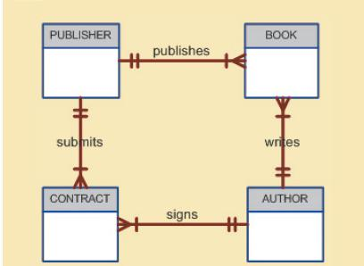

BUSINESS RULES

* A publisher publishes one to many books
* A publisher submits one to many contracts
* A book is published by one and only one publisher
* A book is written by one and only one author
* An author writes one to many books
* An author signs one to many contracts
* A contract is signed by one and only one author
* A contract is submitted by one and only one publisher

**16.**

**Create a Crow’s Foot ERD for each of the following descriptions. (Note that the word**

**many merely means more than one in the database modeling environment.)**

1. **Each of the MegaCo Corporation’s divisions is composed of many departments. Each department has many employees assigned to it, but each employee works for only one department. Each department is managed by one employee, and each of those managers can manage only one department at a time.**



**b. During some period of time, a customer can rent many videotapes from the BigVid store. Each of BigVid’s videotapes can be rented to many customers during that period of time.**

 **c. An airliner can be assigned to fly many flights, but each flight is flown by only one airliner.**



**d. The KwikTite Corporation operates many factories. Each factory is located in a region, and each region can be “home” to many of KwikTite’s factories. Each factory has many employees, but each employee is employed by only one factory.**



**e. An employee may have earned many degrees, and each degree may have been earned by many employees.**



.